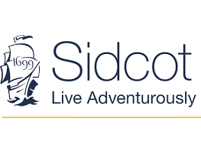
GIFT AID (FOR UK TAX PAYERS)
Increase the value of your donations by 25% at no extra cost to you

Gift Aid is reclaimed by the charity from the tax you pay for the current tax year. Your address is needed to identify you as a current UK taxpayer.
In order to Gift Aid your donation you must tick the boxes below:
Yes - I want to Gift Aid my donation and any donations I make in the future or have made in the last 4 years to Sidcot School
I am a UK taxpayer and understand that if I pay less Income Tax or Capital Gains Tax than the amount of Gift Aid claimed on all my donations in that tax year it is my responsibility to pay any difference.
My details: (Please complete all fields)
Full name _____ ______________________________________
Full home address _______________________________________________________________
________________________________________________ Postcode ______________
Date _________________ Signed:
Please notify Sidcot School if you:
• want to cancel this declaration
• change your name or home address
• no longer pay sufficient tax on your income and/or capital gain
If you pay Income Tax at the higher or additional rate and want to receive the additional tax relief due to you, you must include all your Gift Aid donations on your Self-Assessment tax return or ask HM Revenue and Customs to adjust your tax code
If you have any questions, please contact: Sarah Simms, Director of Marketing and Development: Sarah.simms@sidcot.org.uk
Charity Number 296491
Thank you for your support
Please return this form to:
Sarah Simms, Director of Marketing and Development, Sidcot School, Winscombe, North Somerset, BS25 1PD or email the completed form to alumni@sidcot.org.uk

